Synthesis Writing Fun Packet =)

- Read and annotate the following sources (read the INTRO page too!)

- Develop a Claim. —> Technology ________ isolating.

- Using the sources provided SUPPORT your claim.
Quote #1:_____________________________________
From: Source ______

Quote #2:______________________________________
From: Source_______

- Write 2 paragraphs, Synthesizing (combining) the information from two of the sources supporting your claim.

- Integrate quotes, paraphrase the information, and use illustrations from the sources to support your claim.

- Cite whatever source you use. IN-TEXT citations!
(Cite the sources as “Source A” etc.)

Source A (Rosen)
Source B (Hampton)
Source C (Craig)
Source D (Carral)

Intro page:

Is Technology Making People Less Sociable?

With the spread of mobile technology, it’s become much easier for more people to maintain constant contact with their social networks online. And a lot of people are taking advantage of that opportunity.
One indication: A recent Pew Research survey of adults in the U.S. found that 71% use Facebook at least occasionally, and 45% of Facebook users check the site several times a day.
That sounds like people are becoming more sociable. But some people think the opposite is happening. The problem, they say, is that we spend so much time maintaining superficial connections online that we aren’t dedicating enough time or effort to cultivating deeper real-life relationships. Too much chatter, too little real conversation.

Others counter that online social networks supplement face-to-face sociability, they don’t replace it. These people argue that we can expand our social horizons online, deepening our connections to the world around us, and at the same time take advantage of technology to make our closest relationships even closer.
Larry Rosen, a professor of psychology at California State University, Dominguez Hills, says technology is distracting us from our real-world relationships. Keith N. Hampton, who holds the Professorship in Communication and Public Policy at Rutgers University’s School of Communication and Information, argues that technology is enriching those relationships and the rest of our social lives.

Source A:
Rosen, Larry. “Connecting Virtually Isn’t Like the Real-World Bonding.”
Wall Street Journal. New York, NY. 2015

YES: Connecting Virtually Isn’t Like Real-World Bonding
So that I won’t be branded a Luddite, I will start by saying that I have embraced technology in my life and in my 40 years of teaching. I talk to parents about responsible technology use and educators about enhancing its classroom efficacy.
As a research psychologist, I have studied the impact of technology for 30 years among 50,000 children, teens and adults in the U.S. and 24 other countries. In that time, three major game-changers have entered our world: portable computers, social communication and smartphones. The total effect has been to allow us to connect more with the people in our virtual world—but communicate less with those who are in our real world.
With smartphone in hand, we face a constant barrage of alerts, notifications, vibrations and beeps warning us that something seemingly important has happened and we must pay attention. We tap out brief missives and believe that we are being sociable, but as psychologist Sherry Turkle has so aptly said, we are only getting “sips” of connection, not real communication.
Worse, we don’t even need a beep or vibration to distract us anymore. In one study of more than 1,100 teens and adults, my fellow researchers and I found that the vast majority of smartphone users under 35 checked in with their electronic devices many times a day and mostly without receiving an external alert.
Anxiety drives this behavior. As evidenced by a rash of phantom pocket vibrations, our constant need to check comes from anxiety about needing to know what is happening in our virtual worlds. In one study, we monitored anxiety levels of smartphone users when we wouldn’t let them use their phones, and found that the heavy smartphone users showed increased anxiety after only 10 minutes and that anxiety continued to increase across the hourlong study. Moderate users showed some anxiety, while light users showed none.
If we are constantly checking in with our virtual worlds, this leaves little time for our real-world relationships.
A second issue is the difference between connecting and communicating. While we may have hundreds of Facebook friends—people we never would have met otherwise, with whom we can share many new things—do they really provide the kind of human interaction that is so essential to our emotional health?
Psychologists define social capital, or the benefit we derive from social interactions, in two ways: bonding and the more superficial bridging. Research shows that virtual-world friends provide mostly bridging social capital, while real-world friends provide bonding social capital. For instance, in one study we found that while empathy can be dispensed in the virtual world, it is only one-sixth as effective in making the recipient feel socially supported compared with empathy proffered in the real world. A hug feels six times more supportive than an emoji. We need to examine our technology use to ensure that it isn’t getting in the way of our being sociable and getting the emotional support we need from the people who are closest to us. We need to put our phones away in social settings and consider making phone calls when we want to contact people instead of a series of brief texts. We need to learn to check in less often and seek out face-to-face contact more often.

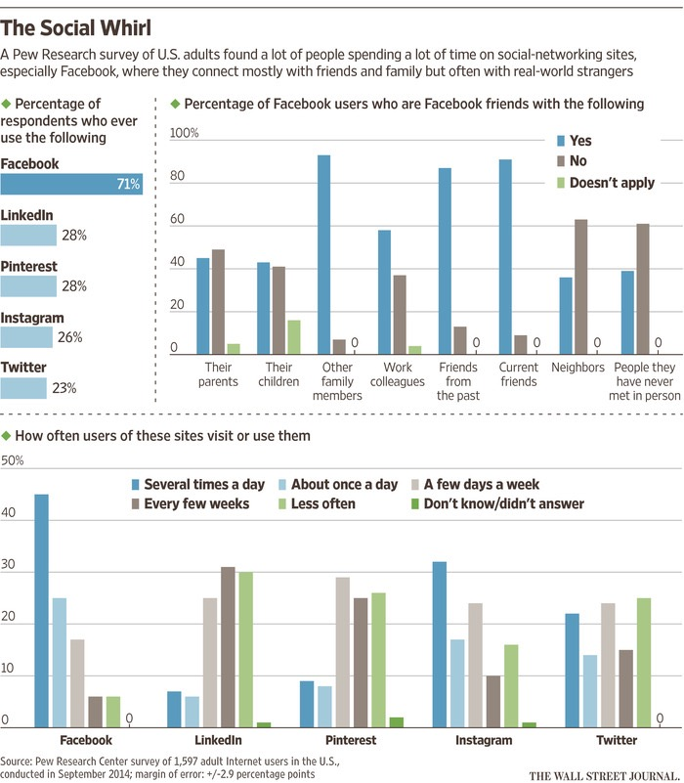

Source B:
Hampton, Keith N. “NO: Relationships Are Being Enhanced, not Replaced.” Wall Street Journal. NY, NY. 2015

Don’t believe the hype. New technologies, including cellphones, the Internet and Facebook, are not making us less social.
Yes, some things have changed—but maybe not as much as you might think. Consider “what a strange practice it is…that a man should sit down to his breakfast table and, instead of conversing with his wife, and children, hold before his face a sort of screen on which is inscribed a world-wide gossip.” These words ring as true today as when they were written, in 1909. They were the observations of one of America’s first and most renowned sociologists, Charles Cooley, about how morning delivery of the newspaper was undermining the American family. Thank goodness the scourge of the newsman is in decline.
We are now no more addicted to communication and ignore our relationships as a result than we did 100 years ago. In studies with my students and collaborators, we have found that Internet and cellphone users, and especially those who use social media, tend to have more diverse and a larger number of close relationships. What has changed is that communication technologies have made many of our relationships more persistent and pervasive. This, in turn, is transforming how we relate to those around us, in what are mostly positive ways.
Social ties that we once would have abandoned as we left high school, changed jobs and moved from one neighborhood to another now persist online. Today, high-school friends stay with us on Facebook in a way that they wouldn’t have done in the past. The same is true for professional acquaintances, distant relatives and friends from all phases of our life. In our closest relationships, today’s technologies don’t replace in-person interaction, they supplement it.
It is tempting to dismiss as trivial many messages exchanged online. But together, the small sips that come from the steady contact of social media can add up to a big gulp of information about the activities, interests and opinions of the people we connect with. They communicate mutual awareness and closeness along with information that we wouldn’t otherwise receive.
We shouldn’t fear information overload as a result. My recent studies have found that even the highest users of email, mobile phones and social media tend not to report higher levels of stress. In fact, for some, especially women, the exchange of informal support and opportunities for social sharing online contribute to lower levels of stress.
All that information also contributes to our awareness of the world around us. Social-media users are more likely to know people from many diverse backgrounds.
We all know of individual cases of technology use that might be problematic, such as that strange practice of some men, or women, sitting down to their breakfast and, instead of conversing with their spouse or children, holding before their faces an actual screen on which is inscribed a world-wide gossip.
But, for the majority of people, most of the time, communication is not a psychological ailment. Technology does not come between us. For most, the persistent contact and pervasive awareness made possible by technology provide a wide range of benefits we have never enjoyed before.

Source C
Craig, Lindsay. “Does Technology Make us more Alone?”
https://www.theodysseyonline.com/does-technology-make-us-more-alone. 2016

Does Technology Make Us More Alone?
In this day and age, it is near impossible to do anything without the use of technology. You can pay your bills, manage your bank accounts and even chat with a customer service representative all with the use of your smart phone.

Is the use of technology starting to take away from our person-to-person interaction? Think about how often you grab your smart phone or tablet and text your friends instead of picking up the phone to call them or, better yet, making plans to hang out in person.
Technology is supposed to make us feel more connected by allowing us to stay in touch with our friends by using social media sites such as Facebook or Twitter and of course, texting. But are our smartphones getting in the way of socializing? Does technology make us feel more alone?
There is a term that is commonly used, "FOMO" -- short for fear of missing out. Yes, this is a real thing. If for some crazy reason you don't check your Twitter or Facebook news feed every 10 minutes are you really missing out?

The fact that we have become so dependent on knowing exactly what is going on in other people's lives is sad. We should be focusing on our own life and our own interactions and relationships with people.
Technology is making us more alone, because instead of interacting with our friends in person, we are dependent on using our phones or tablets. We start to compare ourselves and our lives to others because of how many likes we get on our Instagram photos.
We are forgetting how to use our basic communication skills because we aren't interacting with each other, anymore. We are too busy with our noses in our phones. Young kids are dependent on a tablet to keep them entertained rather than playing with toys. That is not how I want my children to grow up.

As a society, we will start to become very lonely people if we don't start making changes. We are ruining personal relationships because of the addiction to our smartphones and checking our social media sites every five minutes.
It's time for us to own our mistakes and start to change. Next time you reach for your phone, stop yourself. When you are with your friends, ignore your phone and enjoy the company of your loved ones around you.

Technology is a great thing, but it is also going to be the thing that tears us apart as a society if we don't make changes on how dependent we are on it.
Source D
Carral, Hector. “Stop Saying Technology Is Causing Social Isolation” 2015
http://www.huffingtonpost.com/hector-l-carral/stop-saying-technology-is-causing-social-isolation_b_8425688.html

People like to criticize current society. And in this age of information and technology, in which the smartphone is so ubiquitous, it’s only obvious to blame them for some of society’s problems.
Of course, it’s perfectly reasonable to stop and reflect on the use we give to technology and to criticize the bad behaviors associated. But I believe that accusing technology of ruining social interaction and even all kinds of experiences is, to say the least, quite wrong and misguided. Some people would even qualify that as pretentious, but I’ll refrain from that.
If you have used the Internet in the last years (and I suspect you have), you have probably seen a picture on your Facebook feed or on your Tumblr dashboard or nearly everywhere pointing out, with a sense of superiority, how people are slaves of technology nowadays, always using their electronic devices in public.
[…]But I feel that most of that content treats it using the same premise: Smartphones are ruining our lives (at least to some extent).
My main premise is that I don’t think smartphones are isolating us, destroying our social lives or ruining interactions.
I see smartphones as instruments for communication.
Instruments that enable interaction on ways that just weren’t possible before, connecting us with people all around the world, via Twitter, instant messaging or other services. Some may say that if you want to interact with people, you should interact with the ones around you, and that is probably true on certain occasions. But, on other occasions, I’m just not able to comprehend why should we be forced to interact with those physically close to us instead of with the people that we really want to interact with. Is it so bad to prefer talking with a long-distance partner using a smartphone than with someone who does not interest me but happens to be next to me?
To prefer reading how the people you’ve followed by years on Twitter are doing instead of making smalltalk with that friend of a friend sitting across the subway car? Maybe you think that yes, it is bad, that people should always prioritize physical interaction to digital one.
I disagree. I think people should be able to interact with whomever they please without being judged by people for using a smartphone to do so.
Social media itself is also not bad.
It doesn’t make us more socially isolated. Quite the contrary, it expands our social network, as shown in this report by Pew Research Center which concludes:
“Compared to those who do not use the internet, most people who use the internet and use a social networking service, such as Facebook, MySpace, or LinkedIn, have social networks that are about 20 percent more diverse.”
Social media, and smartphones for that matter, only contributes to make our social experiences richer by connecting us with people in new ways. I’m sure many of you have met lots of interesting people. I sure have. Thanks to social media, I’ve been able to meet people that are now close friends of mine. And when I’m out, I like to open
Let’s not fool ourselves. People in general do not like to interact with strangers in these contexts.
They didn’t when smartphones were far from existing; they just used another object instead, like a newspaper.
They also went on to say: digital technology over just the past decade has connected and educated more human minds than probably the entire sum of our planet’s history.
In conclusion, I think we need to stop thinking technology is ruining everything, making us a slave to it, mindlessly using our smartphones all the time. It is not.
It enables us to connect in amazing ways as humans. It is not replacing real interaction. It is augmenting it. Embrace it.

